[](https://ok.ru/dk?cmd=PopLayerPhoto&st.layer.cmd=PopLayerPhotoOuter&st.layer.type=GROUP&st.layer.revNav=off&st.layer.limitedUi=false&st.layer.closeLayers=off&st.layer.sphotoIds=882335998132;882335998388&st.layer.showNav=on&st.layer.photoAlbumId=53539413622964&st.layer.epm=off&st.layer.photoId=882335998132&st.layer.wasRedirect,=off&st.layer.opl=off&st.layer.navStartPhotoId=882335998132&st.layer.sbd=off&st.cmd=userStatuses&st._aid=GroupTopicLayer_openPhotoLayer)

[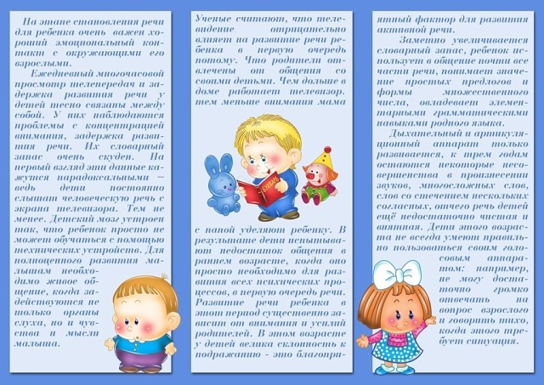](https://ok.ru/dk?cmd=PopLayerPhoto&st.layer.cmd=PopLayerPhotoOuter&st.layer.type=GROUP&st.layer.revNav=off&st.layer.limitedUi=false&st.layer.closeLayers=off&st.layer.sphotoIds=882335998132;882335998388&st.layer.showNav=on&st.layer.photoAlbumId=53539413622964&st.layer.epm=off&st.layer.photoId=882335998388&st.layer.wasRedirect,=off&st.layer.opl=off&st.layer.navStartPhotoId=882335998388&st.layer.sbd=off&st.cmd=userStatuses&st._aid=GroupTopicLayer_openPhotoLayer)